Comment on Wrotham &  Stansted Local Plan Sites | How to comment on individual sites: - To comment on the 50 questions in the Local Plan Strategy, see next page.  Go to TMBC home page and click on "Local Plan Consultation". Scroll down to "Take Part" and then click on "Read and Comment on the Local Plan". On the left side is an index with menu Nos 1-10. Click on "Appendix B: List of Sites" There is the post code of the site in one column and if you now click Site ID Number it will take you straight to the map and some site facts. Wrotham sites are at the end and you can comment on sites in a box at the bottom. Don’t forget Site Reference. Numbers & I suggest you use the box for comments on a single site & rerun for other sites.  You can also send your comments by email to localplan@tmbc.gov.uk

Site No | Wrotham Sites | Location | Category  Applied For | Green Belt | AONB | AONB  Setting | Current  Use Class
59830 | Borough Green Garden City | Wrotham Heath to Ightham | Mixed | Yes | 20% | 80% | Quarrying
59880 | St Mary’s & Bypass | South of Rose Cottage | Residential | Yes | Yes | No | Agriculture
59881 | South Wrotham Bypass | Wrotham Bypass to M26 | Residential | Yes | Yes | No | Agriculture
59707/59731 | South of Kemsing Road | Junc of Kemsing Rd & Borough Grn Rd | Residential | Yes | Yes | No | Agriculture
59712 | Oaktrees BG Road | East of A227 | Employment | Yes | Yes | No | Employment
59680 | West of Marley | London Road | Employment | Yes | No | Yes | Agriculture
59705 | Employment London Rd | South of Invicta Business Park | Employment | Yes | No | Yes | Agriculture
59751 | Old Allotments | West of Howlands | Residential | Yes | Yes | No | Ex Allotments
59681 | Marley Site | Commercial Site in Green Belt | Employment | Yes | No | Yes | Employment
59593 | Excel Bungalow + Rosador? | Next to Nepicar Business Park | Employment | Yes | Yes | No | Residential
59600 | Rosador | Next to Nepicar Business Park | Employment | Yes | Yes | No | Residential
59611 | Spring Tavern Site Demolished | Between A20 and M20 | Employment | Yes | Yes | No | Employment
59643 | Nepicar Oast Garden | Next to Nepicar Oast | Employment | Yes | No | Yes | Employment
59711 | Potters Mede Bungalow Gdn | East of A227, recently consented | Residential | Yes | Yes | No | Housing
59788 | Field south of Solar Farm | West of Ford Place Cottage | Employment | Yes | Yes | No | Agriculture
59665 | Nepicar Mixed Use | Motto HGV Lorry Park Site (refused) | Mixed | Yes | No | Yes | Agriculture
59706 | East strip Nepicar Oast Gardn | Next to Akita Head Office | Mixed | Yes | No | Yes | Res. Garden
 | Stansted Sites
59882 | East of Plaxdale Green Rd | Mid strip development | Residential | Yes | No | No | Agriculture
59883 | East of Plaxdale Green Rd | Mid strip development | Residential | Yes | No | No | Agriculture
59761 | South Ash Rd | North of Golf Course Lake | Residential | Yes | No | No | Agriculture

 | 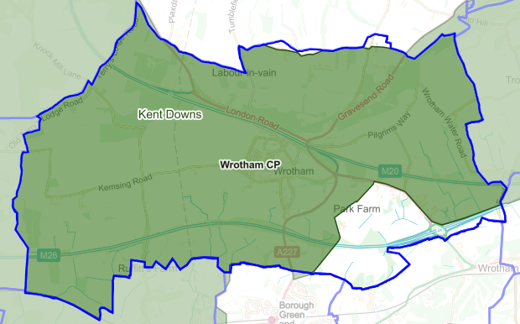  LEGEND |  |  | Commenting on Individual Sites  As you can see from the green area to the left, most of Wrotham is covered by the AONB designation. If you are commenting on a particular site around Wrotham the above list tells you whether AONB or ‘AONB Setting’ applies. All of Wrotham Parish is green belt apart from the village itself. ‘AONB Setting’ means development would be so close to the AONB as to impact on views that the AONB seeks to protect.  Many of you will recognise in the list above, land around the village that has been put forward for development. Just because a landowner has aspirations to get rich, doesn’t mean that land will be developed. In most cases just saying that ‘the site is within the green belt and North Downs AONB and as such is heavily constrained against development in planning terms’, will be enough. My only qualification is that there must be some housing for young families and the Old Allotment Site (59751) which is already designated for development by the previous plan may not be enough.  Borough Green Gardens (59830) is another matter by virtue of it being so huge that it will cause the villages of Wrotham Heath, Platt, Borough Green and north Ightham to coalesce into one urban town, by virtue of the extra 3,000 dwellings. Road junctions are already over loaded, slow traffic creates air pollution that particularly affects children in terms of asthma and other respiratory illnesses.  The concept of trying to build on five active quarries, all at different stages of quarrying, also requiring a road built across all of them early doors, makes this site is a very risky strategy for TMBC. Planning Inspectors have failed one TMBC Local Plan already and at great loss of our Council Tax. To fail a second would be grossly incompetent.  The quarry owners can’t resist extra profits. Borough Green Sandpits have just applied to extend sand extraction until March 2024 (Application Ref. KCC/TM/0195/2022). This will extend the backfilling of the quarry by several years beyond. How can TMBC rely on these quarry men not to make this site undeliverable in the timescale needed? Planning Inspectors have to be convinced a site is deliverable on time. Gross incompetence looms if Inspectors fail the 2nd Plan!
  Wrotham Parish Border
  Area of Outstanding Natural Beauty
Comment on Regulation 18  Strategy Matters- 50 Questions |  | How to comment on the ‘Strategic Matters’ 50 questions. This informs TMBC of your views on the objectives of the Local Plan.  Go to TMBC home page and click on "Local Plan Consultation". Scroll down to "Take Part" and then click on "Read and Comment on the Local Plan". On the left side is an index with menu Nos 1-10. Nos 3-6 contains the list of 50 questions which helps TMBC to shape the Plan’s objectives. You can also send your comments by email to localplan@tmbc.gov.uk  Answers in blue are the personal views of Pete Gillin, which may not coincide with your own views

Q.1 Which elements should feature in the vision for the borough in 2040?  Answer: It is disappointing that there is not greater emphasis on climate change. Houses that are highly insulated, low carbon heating and incorporate significant renewable energy sources.  Q.2 Do you agree that this settlement hierarchy should be retained and inform the spatial strategy for the Local Plan? Yes/No Please explain  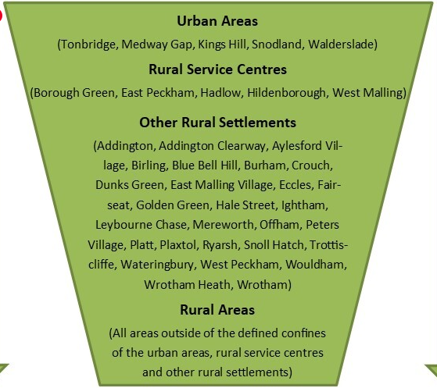  Answer: I agree, the settlement hierarchy has been established in planning policy over decades and reflects the reality of the sustainability of local settlements in terms of transport links and facilities, station, post office etc. | Q.3. Which spatial strategy option do you prefer?  .  Answer: Option 4  Q.4 What are your reasons for selecting this particular spatial strategy option for the Local Plan?  Answer: Option 4 I think that all communities need housing for young families from the locality and see no reason why rural villages should be exempt. There should be a range of housing, including 1 and 2 bed flats and affordable starter homes. Not 5-bed executive housing. The amount of development should be proportionate to the size of the settlement. Option 5 appears to be Borough Green Garden City, which is an option that urbanises the area forming continuous development between Wrotham Heath, Platt, Borough Green and North Ightham.  Q.5. Which quantum option for the spatial strategy do you prefer?  Quantum 1 – Meeting Assessed Housing Need X  Quantum 2 – Meeting Assessed Housing Need + up to 10%  Q.6 Why?  Answer: I selected Quantum 1 as I see no reason to exceed the onerous housing targets set by the current government in the South East  Q.7 Do you agree with the findings of the strategic policy options assessments in Chapter 4 of the Interim Sustainability Appraisal Report? Yes/No Please specify the option and explain.  Answer: Broadly yes but the following two options should be No 1 and 2 and given significant weight. If the earth’s climate continues in its erratic course then no one will be very much worried by the other options at that stage  10: To reduce greenhouse gas emissions so as to minimise climate change  11: To improve adaptation to climate change so as to minimise its impact
   | Select
  A place where the range of housing needs are being met in full and affordability is much improved.
  A place where there are plentiful jobs opportunities, both within the rural and urban economies, to meet the needs of local communities.
  A place with well-designed, accessible, homes and neighbourhoods that are safe, legible, energy efficient and respect the local character.
  A place where people and communities are connected digitally in an effective and reliable way.
  A place where biodiversity thrives alongside communities.
  A place where landscapes and open countryside are respected and can be easily accessed and enjoyed.
  A place where there are plentiful opportunities to enjoy the borough safely and healthily by cycling and walking.
  All are equally important | X
  A place where we never have to watch the Conservatives choose our PM again
  Option 1: Focus development in and adjacent to settlements beyond the outer Green Belt boundary and outside of the Areas of Outstanding Natural Beauty. | This Option seeks to focus development in and adjacent to settlements beyond the outer Green Belt boundary and outside of the Areas of Outstanding Natural Beauty.
  Option 2: Development focused on sites within as well as adjacent to defined urban settlements. | Development would be focused land within the urban areas (as identified in Core Strategy Policy CP11) as well as land adjacent to these settlements.
  Option 3: Development focused on sites within as well as adjacent to defined urban and rural service centre settlements. | In this instance development would be focused on land within the urban areas and rural service centres. This seeks to locate development in areas with good access to existing services and facilities.
  Option 4: Development focused on sites within as well as adjacent to defined urban, rural service centres and other rural settlements to support a range of communities. | This Option supports a distributed pattern of development across the borough. All communities from towns to rural service centres to villages would have some development, hopefully in proportion to the size of the community.
  Option 5: Development focused on sites within existing defined urban, rural service centres and other rural settlements, plus a new settlement/s. | This option includes all of the settlements in option 4 as well as building new garden cities.
Q.8. Do you agree with the findings of the individual site assessments in Appendix D of the Interim Sustainability Appraisal Report? Yes/No Please explain and quote the individual site reference number  Answer: I do not agree with the methodology used by this study. For example the Borough Green Gardens site is treated as a single unit spatially. In reality it is 5 different quarries all at different stages of quarrying. There is no point in ticking a box twice because part of the site is close to a station if the other end of the site is miles away. There is no point on ticking a box because there is a local school when it is obvious that an extra 3,000 families will need multiple new school forms and huge infrastructure that’s currently not present.  It would be far better to make a serious attempt to quantify the infrastructure required, including an end to end ‘Relief Road’, and estimating costs it in order to determine if the proposal is even viable.  Can a road be built in time given that the quarries keep extending their time horizon to complete quarrying?  Strategic Matters  We have identified the following list of strategic matters (in alphabetical order) that we think are relevant to Tonbridge and Malling and need to be addressed in the Local Plan. Let us know if you think this is the right set of strategic matters that the Plan needs to address.  • Built and historic environment  • Climate change  • Community facilities and infrastructure  • Economic development  • Green Belt  • Housing  • Natural environment  • Retail  • Tonbridge (as the borough’s principal town centre)  • Transport  Q.9 Do you agree with this set of strategic matters? Yes/No. Please explain  Answer: Yes but in addition to Green Belt, AONBs are important due to the presence and proximity of the Kent Downs Area of Outstanding Natural Beauty.  Q.10 Which strategic matters should be priorities in the Local Plan?  Q.11. What are your reasons for selecting these particular strategic matters as priorities for the Local Plan (outline briefly)?  Answer:  Climate Change- To save the planet  Green Belt- Preserving its openness is critically important  AONB- Preserving the innate beauty of these areas is critically important. They must be preserved such that urban and country dwellers can escape to beautiful areas for fresh air and exercise. | Q.12. With reference to your answers to questions 3 and 4, do you agree that the housing requirement for the Local Plan should involve meeting the identified housing needs in full, as a minimum? Yes/No Please explain  Answer: I do not agree. National government inflates the housing market prices by declaring stamp duty holidays. This does not affect housing in cheaper and generally northern areas because those houses are below the stamp duty threshold. It boosts the market in London and the South East and the nearer to London the more impact. It is perverse for the government to artificially inflate local house prices and then fill the southeast with housing development in a vain attempt to bring prices down.  It is better to pursue a levelling up policy and spread the housing requirement across the country, irrespective of local housing cost.  Q.13. Do you agree that the Local Plan should allocate a mix of sites (small, medium, and large) to help maintain supply throughout the plan period? Yes/No Please explain.  Answer: Disagree. There should be a mix of site size but putting reliance on sites that provide of the order of 25% of the total housing need or more, is inherently a risky strategy. Unforeseen site specific circumstances can cause the whole Local Plan to fail if a significant quantum of housing land cannot be developed.  To put reliance on a collective group of active quarries that are still mining sand, to the tune of 43% of housing need is tantamount to playing Russian roulette with a Local Plan. For Planning Inspectors to fail one Local Plan could be seen as unfortunate, if they condemn another it would be gross incompetence.  Or we go for ‘3rd time lucky’, in the manner that Conservatives select PMs.  Q.14. Do you agree that the Local Plan should require a specified mix of dwelling types (eg flatted, terraced, semi-detached, detached) on large development sites to meet the range of households’ needs? Yes/No Please explain  Answer: Yes, it should reflect the mix of accessed need.  Q.15. Do you agree that the Local Plan should require a proportion of plots on large developments to be made available for self-build and custom house building? Yes/No Please explain  Answer: Yes as it fulfils a housing need and promoted variety and hopefully good design.  Q.16. Do you agree that the Local Plan should require a proportion of homes on large development sites to be Build-to-Rent products? Yes/No Please explain  Answer: Yes as it fulfils a housing need.  Q.17 Do you agree with the windfall allowance methodology? Yes/No Please explain  Answer: Yes because unpredicted sites come forward year on year..
  Strategic Matters (alphabetical order) | Select Three
  • Built and historic environment
  • Climate change | X
  • Community facilities and infrastructure
  • Economic development
  • Green Belt | X
  • Housing
  • Natural environment
  • Retail
  • Tonbridge (as the borough’s principal town centre)
  • Transport
  • Built and historic environment
  • OTHER : AONB | X
Q.18 Which housing matters are most important to you?  Answer: I do not see the point of this question and how it could possibly be useful. The scope of the 19 ‘matters’ is far too broad and covers unrelated criteria.  Q.19 What are your reasons for selecting these particular housing matters as priorities for the Local Plan (outline briefly)?  Answer: Development should be infrastructure led and be in place before a single house is sold. Only then will we get communities to accept proportionate development.  Economic development – what are the issues?  Key economic development issues which the Local Plan can help to address  - High land values and a shortage of employment land and premises for established and growing businesses as well as those looking to locate in the borough.  - Lack of investment in strategic infrastructure and congestion on local transport networks.  Q.20 Do you agree with the key economic development issues identified above? Yes/No Please explain  Answer: I disagree there is a shortage of premises. Much of the commercial parts of Kings Hill had to be reallocated to housing due to lack of demand. Oakdene Business Park has more un-let premises than let.  There is a lack of investment in infrastructure and particularly the strategic road network. Whitehill, Gravesend and Nepicar roundabouts have queues hundreds of metres long on some arms at peak times. Businesses rely on an efficient primary road network. | KEY TRANSPORT ISSUES  - Bus - Provide funding to establish new bus services which can become commercially sustainable.  - Rail - Improve access to and facilities at local stations, especially for cycling, walking and disabled passengers.  - Cycling - Improve the availability of dedicated and segregated cycle routes across the borough.  - Walking – Improve the footpath network especially in rural locations where pavements may be inadequate and provide safe crossings.  - Roads - Provide additional road and junction capacity only where this is necessary.  - Parking – The provision of sufficient parking in residential developments and urban areas.  Q.21 Do you agree with the key transport issues identified above? Yes/No Please explain  Answer: Everyone would like all of the above. The reality is there is no funding. KCC have just significantly cut bus subsidies that have led to swathing cuts in services.  If you can get people to stations the commuter trains are standing room only at present in peak times.  Q.22 Which transport issues matter the most to you?  Answer  1. Bus services.  2. Junction improvements on the Whitehill, Nepicar and Gravesend Road Roundabouts  Q.23 What are your reasons for selecting these particular transport issues as priorities for the Local Plan (outline briefly)?  Answer  1. Bus services are essential for children to get to school and for reducing car dependence. It can improve air quality and reduce CO2 emissions by reducing individual car use.  2. At present we do not have good public transport but we do have massive queuing at road junctions around Wrotham. Idling vehicles causes pollution and poor air quality.  Q.24 Would you support the implementation of cycling and walking schemes where a reduction in road space including on-street parking may be required in some instances, to provide a network of high-quality urban cycle routes?  Answer: In an urban scenario yes. It is proven to reduce traffic in places like Cambridge and many European cities. The A20 has too many lanes that encourages overtaking, on Wrotham Hill for example. There should be two lanes and safe, separated cycleways.  Tonbridge-What are the issues?  Option 1: Maximise build densities on development sites within Tonbridge, particularly on those sites within the town centre, maximising their potential. This would minimise the need for the release of green field sites beyond the outer edge of Tonbridge, in the Green Belt, for development.  Option 2: Keep build densities as they are. This would increase the need for the release of green field sites at and beyond the outer edge of Tonbridge, in the Green Belt, for development.  Q.25 What is your preferred strategy option for Tonbridge?  Answer: Option 1.  Q.26 What are your reasons for selecting this particular strategy option for Tonbridge (outline briefly)?  Answer: In order to minimise development in the Green Belt I am in favour of building at higher densities in the centre of urban areas. The density should then reduce as you get further from the centre. At the edge of the urban areas the density should drop in order to sympathetically meet the countryside.
  Housing Matter (alphabetical order) | Select Five
  Accessible housing (eg for wheelchair users)
  Affordable housing – to buy
  Affordable housing – to rent | X
  Build to Rent
  Density of housing development
  Distribution of housing across the borough (taking account of where the needs are generated) In proportion to size of community | X
  First-time buyers’ housing
  Garden communities | NO
  Home-working opportunities
  Infrastructure (schools, roads, healthcare, open space etc) supporting new homes delivered in a timely fashion | X
  Modern Methods of Construction (MMC)
  Self-build and custom housebuilding
  Size of housing (1-bedroom, 2-bedrooms, 3+ bedrooms)
  Size of housing sites
  Specialist housing for people with particular care needs | X
  Tenure of housing (market purchase/private rent/affordable rent) | X
  Travelling Showpeople accommodation
  Type of housing (flat/house)
  Other – please state and include
Q.27. What should be the main role of Tonbridge Town Centre moving forward? Should the priority be for shopping or for leisure, social and cultural uses or a balance of these?  Answer: A balance of all,  Q.28. Should the Local Plan include a more flexible policy framework for Tonbridge to allow the Town to respond to future market investment opportunities for a range of land uses and developments? Yes/No  Answer: Yes  Q.29. Do you have other thoughts about how planning policy should guide development in and around the town centre?  Answer: No  Key retail issues which the Local Plan can help to address:  - Positively support change which supports the role of the borough’s retail centres and rural service centres, making them attractive places to visit.  - Provide policy flexibility to support the challenges and opportunities faced by each retail centre and the rural service locations.  - Consider how land can be allocated for retail and mixed-use development to meet identified needs.  Q.30. Do you agree with the key retail issues identified above? Yes/No Please explain  Answer: Yes  Q.31. Is there anything more that the council could do to make the borough’s retail centres more attractive and successful? Yes/No Please explain.  Answer: No  Key priorities for the Local Plan:  - Identifying the required infrastructure to support the scale and locations for growth within the Borough  - Aligning infrastructure provision in line with this growth  - Maintaining and enhancing the existing provision of infrastructure that communities rely upon  Q.32. Do you agree with this set of community facilities and infrastructure priorities? Yes/No Please explain  Answer: Yes, completely agree with development being infrastructure led.  Q.33. Should Local Green Space be designated in the Local Plan? Yes/No  Answer: Yes, in order to achieve a coherent and connected green spaces to encourage wildlife and bio  diversity.  I suggest that the Wrotham Viewing Point at the top of the hill should be reopened as pedestrian only area with CCTV to deter the previous antisocial behaviour. It must then be regularly maintained by TMBC. | Q.34. If yes, do any potential sites meet all of the criteria set out in NPPF?  Answer: The Ightham Sandpit is a restored quarry that has a substantial population of Great Crested Newts.  It is a beautiful area with numerous lakes and wetlands and is naturally rewilding.  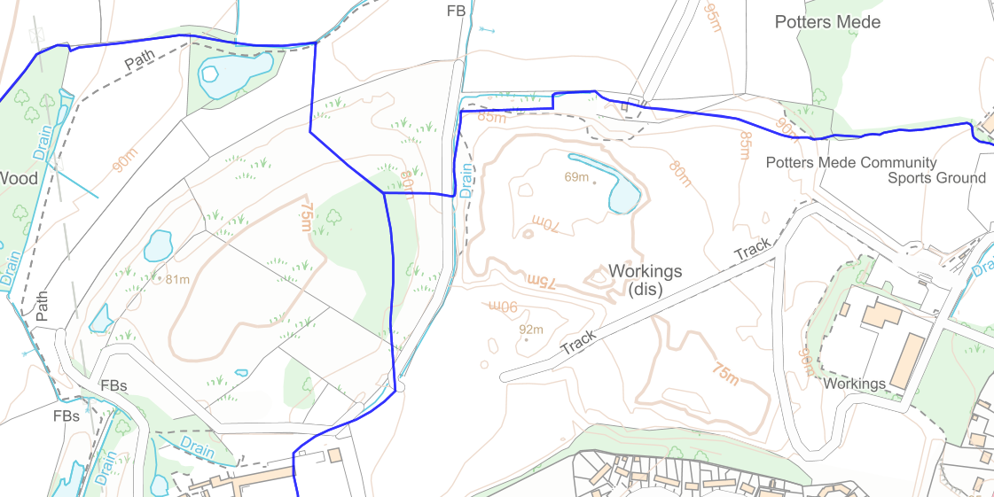  Q.35. Should the council be seeking more than 10% Biodiversity Net Gain, if viable? Yes/No  Answer: Yes, of course. TMBC could be a beacon Planning Authority with 15% BNG.  Q.36. Should the council allocate sites specifically for Biodiversity Net Gain within the Local Plan? Yes/No  Answer: Yes and this can be part of the green space strategy from Q.33  Q.38. What are your reasons for selecting these particular design matters as priorities for the Local Plan (outline briefly)?  Answer: Developments should be sympathetic to local character to preserve the uniqueness of our individual communities. Good design is visually attractive.
  Design matter (in no particular order)
  Developments that will function well and add to the overall quality of the area for the lifetime of the development
  Developments that are visually attractive | X
  Developments that are sympathetic to local character, history and landscape settings | X
  Developments that establish a strong sense of place and identity | X
  Developments that optimise appropriate density and scales
  Developments that create safe, inclusive and accessible places that promote health, well-being and have good facilities
  All are equally important
Local – Historic environment  Q.39. Are there any other locally significant built, historic issues or sites which you consider are important to the borough and should be addressed in the Local Plan? Yes/No Please explain  Answer: Still considering  Local – Green Belt coverage exceptional circumstances case (strategic) for change  5.11.7 This section highlights a set of factors that need to be taken into account when reviewing the existing Green Belt boundaries to determine if exceptional circumstances exist to justify local alterations. These are:  - National policy (purposes of the designation and the need to promote sustainable patterns of development)  - case law  - Housing Market Areas  - housing affordability  - policy and environmental constraints  - assessed development needs  - housing supply  - potential for development in the built-up areas (Urban Capacity Study).  We would like to understand if you agree with this set of factors and whether any have been omitted that are relevant to this review process.  Q.40. Do you agree that there are exceptional circumstances, at the strategic level, for altering Green Belt boundaries (in principle) to help address assessed development needs? Yes/No Please explain.  Answer: Strongly disagree at the strategic level. The purpose of Green Belt policy is to restrict the metropolitan urban sprawl by creating a Green Belt around the metropolis. In this belt the ‘openness’ is considered crucially important and this is emphasised by the fact that a Planning Authority can only consider changes if there are ‘extraordinary circumstances’ to support that proposal. This is a very high bar and the contention that a site that is within the green belt should be developed instead of a site a few miles away but outside of the green belt and in another ‘housing market area’ is quite simply wrong and possibly unlawful. Certainly, in our view, consideration of alternative sites for housing that are unconstrained by green belt should be made before green belt sites.  Q.41. Do you agree with that the set of factors listed in para. 5.11.7 should be used to determine if exceptional circumstances exist to justify alterations to Green Belt boundaries? Yes/No. If no, please explain, highlighting additional/alternative factors that you consider need to be included in the review process.  Answer: No. The strategic level is just part of the consideration and site specific considerations are critically important. Exceptional circumstances could only be determined after a careful study of the proposed site and what the exceptional benefits are that the development proposal brings compared with the disbenefits. All aspects of the individual site must be considered and each site is different. For example the building of significant numbers of dwellings on a particular site will often cause some or all of the following disbenefits.  - The dwellings will significantly increase traffic which may overload primary network junctions.  - The impacted junctions cause crawling traffic and decreases air quality, potentially exacerbating AQMAs.  - Significant developments can infill between separate village communities, effectively urbanising rural areas, which is the opposite of the purpose of the Green Belt policy. | 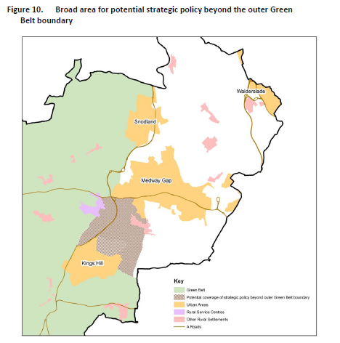  Q.42. Area beyond outer Green Belt boundary – strategic options.  Answer: Option 2  Q.43: What are your reasons for selecting this policy option for the area beyond the outer Green Belt boundary (outline briefly)?  Answer: ‘Strategic Gaps’ are an established policy that can easily be implemented. Changes to the long established Metropolitan Green Belt are difficult to achieve as they require ‘exceptional circumstances’ to justify changes.  We should value the separation of our rural communities, not just in the north east but in areas between Wrotham Heath, Platt, Borough Green, Ightham and Wrotham.
  Strategy | Preferred Option | Please Select
  Option 1 | Extend the outer boundary of the Green Belt
  Option 2 | Anti-coalescence/strategic gap policy | X
  Option 3 | No change – leave existing outer Green Belt boundary unaltered.
Climate change – what are the issues?  The Government has taken positive steps this year to help achieve the objective of lowering carbon emissions from developments. On 15 June 2022, changes to the Building Regulations (conservation of fuel and power) came into effect which require the CO2 emissions from new homes to be around 30% lower than the previous standards. In addition, emissions from other new buildings, including offices and shops, are required to achieve a 27% reduction. These changes are part of the Government’s road map to deliver the Future Homes and Buildings Standards by 2025. The Future Homes Standard will ensure that the average home from 2025 onwards will produce at least 75% lower CO2 emissions than one built to the Building Regulations, pre-June 2022 changes.  Q.44. Do you agree that the Local Plan should set requirements for a certain proportion of development on major sites to be built using MMC? Yes/No Please  Answer: Disagree. The government have set stringent targets for CO2 emissions phased over the next 3 years via Building Regulations. MMC (factory built housing) is just one way to achieve this goal and a mix of insulation and renewable energy in new housing is an alternative. The government should set the targets and Architects and Buildiers should be free to design housing as they see fit, provided they conform to building control regulation.  Kent County Council’s Plan Tree Strategy36 which has an ambition of extending the county’s tree cover by 1.5 million, establishing one new tree for every resident living in the county. As well as providing habitats for an array of flora and fauna, the right trees at the right places can provide shade to buildings – reducing the need for mechanical air cooling – and act as carbon sinks. The Government recognises that trees can help mitigate and adapt to climate change  As well as boosting tree coverage, we understand that other forms of vegetation and landscaping, e.g. hedgerows, can play an important role in supporting biodiversity and allowing species to adapt to the effects of climate change. We are also mindful of the need to consider how the fabric of new buildings can make space for nature through opportunities for habitat creation for wildlife such as migratory birds.  Green infrastructure can help manage flooding through sustainable drainage and attenuation and help species adapt to climate change. Furthermore, making space for nature by boosting habitat creation and, therefore, biodiversity can benefit the well-being of residents by allowing them to connect with nature.  Q.45. Do you agree that the Local Plan should set a minimum requirement for tree canopy coverage on new developments? Yes/No Please explain.  Answer: Yes, for the following reasons:  - Green trees are good for residents well being  - Absorb CO2 emissions, so good for climate change  - Provide habitat for wildlife  - Absorb rainwater excesses so are good for Sustainable Urban Drainage (SUDS) schemes and help flood relief  Q.46. Do you agree that new developments should integrate into the fabric of buildings habitat space for wildlife, such as migratory birds?  Answer: Yes, there are proprietary bat and bird nest units that can be built into the outer wall fabric at high level to provide nests for breeding birds and roosts for bats. The units are sealed and designed to contain the creatures in a confined location in a quiet part of the upper elevations. | Q.47. Which climate change measures are most important to you?  Q.48. What are your reasons for selecting these particular climate change measures as priorities for the Local Plan (outline briefly)? explain  Answer: It is a climate emergency and those 3 will have the most significant effect on mitigating CO2 generation. However all measures are important.
  Climate change measures (alphabetical order) | Select (3 in total)
  Local electrical generation, PV Panels & Wind turbines | X
  Energy efficient, future-proofed buildings | X
  Habitat creation – built fabric (eg swift bricks)
  Habitat creation – natural (eg meadows, hedgerows)
  Modern Methods of Construction (MMC)
  Multi-functional green infrastructure (recreation, carbon sinks and biodiversity net gain)
  Passive design (orientation, layout, landscaping)
  Sustainable drainage systems (SuDS) (eg green roofs, water butts, retention ponds)
  Tree coverage – increased.  Plant forests over back filled quarries | X
  Other –
Local requirements – priorities  In question 49, can you please select five requirements that are most important to you. We do not expect you to rank these in order of importance. This does not mean that the remaining issues are not relevant; however, the Local Plan will need to set some priorities and give guidance on where the focus should be, bearing in mind the issue of viability and the cumulative impact of requirements on the delivery of development  Q.49. Which local policy requirements are most important to you?  Please identify 5 | Q.50 What are your reasons for selecting these particular local requirements as priorities for the Local Plan (outline briefly)?  Answer: I don’t consider many of the options relevant to issues of viability for the Local Plan.  Several options are either a requirement under planning regulation or under building regulation and therefore irrelevant for plan making.  Climate change should be the top priority in all aspects of planning development expansion
  Local requirement (alphabetical order) | Priority  (please identify 5)
  Accessible and adaptable housing (disabled and elderly) | X
  Active travel (cycling and walking)
  Affordable housing – to buy
  Affordable housing - for rent
  Biodiversity & Ecology
  Energy efficiency | X
  First Homes
  Indoor recreation facilities
  Internal space standards
  Modern Methods of Construction
  Parking
  Public open space
  Renewable energy generation (eg photovoltaic cells) | X
  Safety and security
  Self-Build and/or Custom Housebuilding
  Specialist housing (elderly, eg care homes) | X
  Sustainable Drainage (eg water butts and green roofs)
  Water efficiency (consumption within the home)
  Other – Climate Change and reducing CO2 emissions | X

